Anniversary Photography Exhibition
"Hometown in Light and Shadow, The World through Stories"
Submission Guidelines & Examples
Eligibility: International students of Hungkuang University
Submission Requirements:
- Submit 2–3 photos (or more) or one video, accompanied by a written story (see example) and a brief description in Mandarin.
- Recommended resolution: 300 dpi or above, file size between 1MB to 5MB.
Submission Method & Deadline
- Submission Email: pr@hk.edu.tw
- Deadline: October 31, 2025 (Friday)
Awards for Accepted Works
- Accepted works will receive a meal voucher
(redeemable at HK Restaurant or More Fun Express)
- Accepted works will be exhibited or screened in the Second Conference Hall on November 29, 2025 as part of the 58th Anniversary Celebration of Hungkuang University.
Notes
- Please carefully read and sign the Copyright Authorization Agreement
- Submitted photos or videos must be the original work of the photographer.
- By submitting, participants consent to the university’s use of the materials for exhibition or promotional purposes during the event.

Copyright License Agreement
I. Work Category: □ Photo □ Video
II. License Content
I hereby grant Hungkuang University a free license to publicly display and use my submitted work(s) in on-campus exhibitions and related non-profit activities. This license is unlimited in time and territory but restricted to academic exchange, cultural promotion, and campus activities. It shall not include any commercial use.
III. Copyright Statement
- I declare that the submitted work is my original creation, does not infringe upon the intellectual property rights of any third party, and that I hold the full rights to grant this license. If the work involves co-creators or requires third-party consent, I confirm that such consent has been obtained. I accept full responsibility for any disputes or legal issues arising from false declarations.
- This agreement grants a non-exclusive license. Hungkuang University obtains only the right to use the work. I retain the right to authorize others to use it. However, if the work has been exclusively licensed to another entity, I may not sign this agreement.

Licensor (Signature):
ARC Number:
Department:
Student ID:
Address:
Phone:
Date:

Photographer’s Photo
 | Photographer’s Name: Xiaomei Nationality: Taiwan  Phone Number:  E-Mail:

Submission Example ★ Please attach the original photo files and send them together to pr@hk.edu.tw
photo | Photo Story
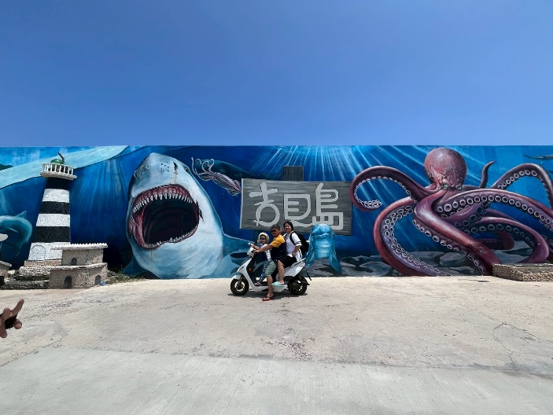 | Photographer’s Name: Xiaomei  Location: Penghu  Photo Story:  Taiwan’s beautiful outlying island, featuring stunning beaches and crystal-clear waters.
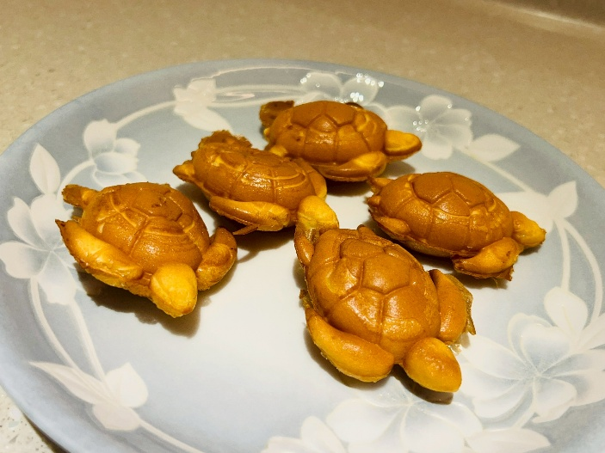 | Photographer’s Name: Xiaomei  Location: Penghu  Photo Story:  The clean seawater has made this place a habitat for many sea turtles, and even the sponge cakes are shaped like turtles.
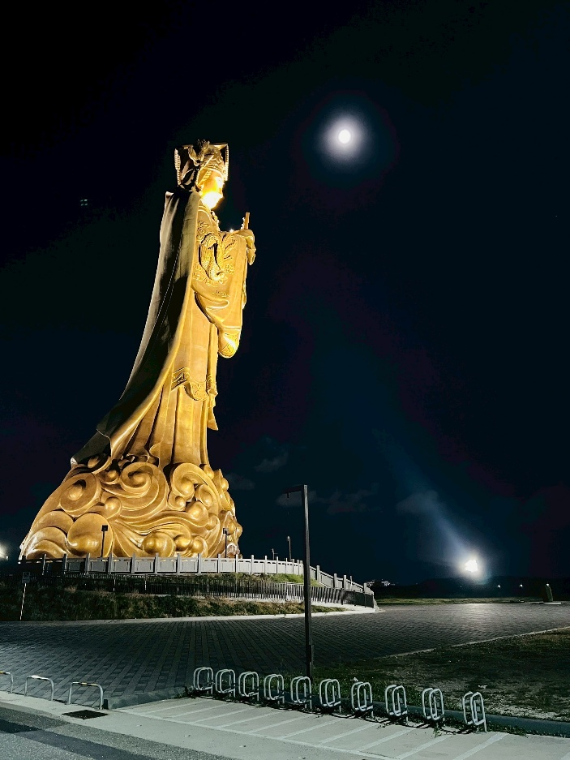 | Photographer’s Name: Xiaomei  Location: Penghu  Photo Story:  Chongguang Mazu Statue.  “Mazu” is one of Taiwan’s important beliefs. Traditionally worshiped for safe voyages and abundant fishing harvests, today people also pray to Mazu for smooth journeys, good health, happy marriages, prosperity in career and wealth, and harmony in the family.

★ Please attach the original photo files and send them together to pr@hk.edu.tw
photo | Photo Story
Photographer’s Name:
Location:
Photo Story:
Photographer’s Name:
Location:
Photo Story:
Photographer’s Name:
Location:
Photo Story:

